Summary - Int 5, Group A, 𝚫𝚫G Version

Inbal Lorena Eshel

17/03/25

## *Water*

### Model 3P

| formula | R.sq | Q.sq | MAE |
| --- | --- | --- | --- |
| ddg ~ NPA_42 + Total_1 + B1_9_3 | 0.885 | 0.813 | 0.361 |
| ddg ~ NPA_42 + dip_y_1 + Total_1 | 0.873 | 0.791 | 0.365 |

***3-Fold cross-validation***

| Q2 | MAE |
| --- | --- |
| 0.724 | 0.452 |

***Multicollinearity check***

|  | x |
| --- | --- |
| NPA_42 | 1.227 |
| Total_1 | 2.206 |
| B1_9_3 | 2.226 |

***Scaled Coefficients:***

|  | Estimate | Std. Error | t value | Pr(>|t|) |
| --- | --- | --- | --- | --- |
| (Intercept) | 1.122 | 0.092 | 12.155 | 0.0000000 |
| NPA_42 | 0.955 | 0.105 | 9.077 | 0.0000003 |
| Total_1 | -0.956 | 0.141 | -6.776 | 0.0000089 |
| B1_9_3 | 0.481 | 0.142 | 3.397 | 0.0043425 |

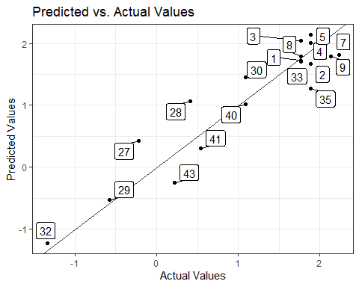

## *Methanol*

### Model 3P

| formula | R.sq | Q.sq | MAE |
| --- | --- | --- | --- |
| ddg ~ NPA_42 + dip_y_1 + Total_1 | 0.814 | 0.644 | 0.513 |

***3-Fold cross-validation***

| Q2 | MAE |
| --- | --- |
| 0.585 | 0.558 |

***Multicollinearity check***

|  | x |
| --- | --- |
| NPA_42 | 1.858 |
| dip_y_1 | 2.901 |
| Total_1 | 2.198 |

***Scaled Coefficients:***

|  | Estimate | Std. Error | t value | Pr(>|t|) |
| --- | --- | --- | --- | --- |
| (Intercept) | 1.122 | 0.117 | 9.566 | 0.0000002 |
| NPA_42 | 1.081 | 0.165 | 6.570 | 0.0000125 |
| dip_y_1 | -0.809 | 0.206 | -3.936 | 0.0014918 |
| Total_1 | -1.073 | 0.179 | -5.996 | 0.0000328 |

